Functional Holography of Recorded Neuronal Networks Activity

Itay Baruchi¹ and Eshel Ben-Jacob^{1,2}
(1) School of Physics and Astronomy
Beverly and Raymond Sackler Faculty of Exact Sciences
Tel Aviv University, 69978 Tel Aviv Israel
(2) Kavli Institute for Theoretical Physics,
Kohn Hall, University of California at Santa Barbara
Santa Barbara, CA 93106 U.S.A.

Abstract:
We present a new approach for analyzing multi-channel recordings such as ECoG (electrocorticograph) recordings of cortical brain activity and of individual neuron dynamics in cultured networks. The latter are used here to illustrate the method and its ability to discover hidden functional connectivity motifs in the recorded activity.

The cultured networks are formed from dissociated mixtures of cortical neurons and glia-cells that are homogeneously spread over multi-electrode array for recording of the neuronal activity. Rich, spontaneous dynamical behavior is detected, marked by the formation of temporal sequences of synchronized bursting events (SBEs), partitioned into statistically distinguishable sub-groups, each with its own characteristic spatio-temporal pattern of activity.

In analogy with coherence connectivity networks for multi-location cortical recordings, we evaluated for each sub-group the inter-neuron correlation-matrix. Ordinarily such matrices are mapped onto a connectivity network between neuron positions in real space. In our functional holography, the correlations are normalized by the correlation distances – Euclidian distances between the matrix columns. Then, we project the N-dimensional (for N channels) space spanned by the matrix of the normalized correlations, or correlation affinities, onto a corresponding 3-D manifold (3-D Cartesian space constructed by the 3 leading principal vectors of the principal component algorithm). The neurons are located by their principal eigenvalues and linked by their original (not-normalized) correlations. By looking at these holograms hidden causal motifs are revealed: each SBEs sub-group generates its characteristic connectivity diagram (network) in the 3-D manifold, where the neuron locations and their links form simple structures. Moreover, the computed temporal ordering of neuron activity, when projected onto the connectivity diagrams, also exhibits simple patterns of causal propagation. We show that the method can expose functional connectivity motifs like the co-existence of sub-neuronal functional networks in the space of affinities.

The method can be directly utilized to construct similar causal holograms for recorded brain activity. We expect that by doing so, hidden functional connectivity motifs with relevance to the understanding of brain activity might be discovered.

1. Introduction
Much effort is devoted to revealing the underlying functional connectivity and information processing motifs of brain activity [Bishop, 1999; Dayan and Abbot, 2001, Kandel, 2003]. A research methodology toward this goal is to construct connectivity networks from parallel recording from many locations and evaluate the corresponding activity-correlation (coherence) matrices. Investigations of such multi-electrode recordings range from the basic micro-level of isolated, self-formed cultured networks, through the meso-level of isolated, pre-formed slices, to the macro-level of the brain cortex [Hilgetag et al., 1996; Towle et al., 1999; Hilgetag et al., 2000; Stephan et al., 2000; Netoff and Schiff, 2002; Gluckman et al., 2001; Milton and Jung, 2002; Segev et al. 2001a,2001b,2002,2003,2004].

The new functional holography method presented here was developed from the perspective of cultured networks. Yet it is also applicable for the analysis of slices and cortex recorded activities and other correlation matrices. Moreover, it makes it possible to place the recordings from all of these levels within the same presentation schema, for comparative studies.

The advantage of cultured networks is that they provide relatively simple, well-controlled systems for the micro-level investigations, using multi-electrode array (MEA) for recording the individual neurons activity at different locations [Segev et al, 2002]. In addition, by lithographic methods, one can study networks with a pre-specified area ranging from ~0.01mm² (small) through ~1mm² (medium) to ~100mm² (large), with a corresponding specified number of neurons ranging from ~ 10² through ~ 10⁴ to ~ 10⁶. Therefore, they can be directly and even quantitatively compared with model simulations [Volman et al, 2004, Persi et al, 2004] on one hand, and with recorded brain activity on the other hand. These in vitro networks exhibit rich spontaneous dynamical behavior marked by the formation of synchronized bursting events (SBEs), each with its own internal pattern of neuronal activity [Segev et al, 2002, 2003, 2004, Hulata et al 2001,2004].

It has been shown that hidden sub-groups of SBEs can be found in the large networks activity when the inter-SBEs correlation matrices are reorganized with the dendrogram clustering algorithm [Segev et al. 2003b]. The latter reorders the recorded sequence, so that bursts with similar internal patterns of neuronal activity (higher correlations) are closely located. Once the SBEs are sorted into distinct sub-groups, it is possible to show that each has its own characteristic temporal propagation of the neurons activity as well as its own characteristic inter-neuron correlation matrix. For comparison with connectivity networks constructed from recorded brain activity, each correlation matrix can be mapped onto a connectivity network in real space by locating the neurons according to electrode positions and linking them by their correlations, as shown in Fig1.

Here we present a new approach that makes it possible to identify additional motifs embedded in the inter-neuron correlation matrices – analogous to the inter-location coherence matrices evaluated for ECoG recordings of brain activity [Towle et al, 1999, Milton and Jung, 2002], that are not transparent in the real space connectivity networks. In the new method, the correlation matrix is represented in a higher dimensional space of functional correlations, or correlation affinities. The latter are the inter-neuron correlations normalized by the corresponding correlation distances between the activities of each two neurons. Next, we construct a three dimensional functional manifold of the high dimension space of affinities so that it contains the maximal information about the affinities. This is done by using the standard principal components algorithm to construct a Cartesian three dimensional space whose axes are the three leading eigenvectors. Finally, to generate the causal holograms, the neurons are positioned in this space according to their eigenvalues, and each two of them are linked by a line whose color represents the naked correlation (not normalized), between them.

Using this schema to analyze the cultured networks activity, we found that each sub-group of SBEs generates its own characteristic hologram (functional diagram). The diagrams have surprisingly simple graph structures, both in terms of the neuron locations and the organization of the correlation links. Also revealed is a new correspondence between the functional diagram and the way the neurons activity propagates along its structure.

The co-existence of distinct sub-groups of SBEs might suggest the existence of new schemata of hybrid information processing - coding, storage, generation and retrieval of information. The idea is that each SBE, with its own functional diagram, can provide a template for handling a specific task of information processing when the network is coupled to other networks.

2. Multi-electrode recordings of cultured networks activity
For multi-channel recordings of cultured networks activity, dissociated cultures of mixed cortical neurons and glia cells drawn from one-day-old Charles River rats [Segev et al. 2002], are homogenously spread over a lithographically specified area on top of a multi-electrode array (MEA) of 60 electrodes. Consequently, the neurons send dendrites and axons to form a wired network. Although this process is self-executed with no externally provided guiding stimulation or chemical cues, a relatively intense dynamical activity is spontaneously generated within several days. The activity is marked by the formation of synchronized bursting events (SBEs) – short (~200ms) time windows during which most of the recorded neurons participate in relatively rapid firing. These SBEs are separated by long intervals (above seconds) of sporadic neuronal firing.

3. Identifying Distinct sub-Groups of SBEs
To check whether the SBEs can be sorted into distinct sub-groups with similar internal patterns of neuronal activity, we first evaluate the inter-SBE correlation matrix (or event correlations), EC(n,m) [Segev et al., 2004], by

$\text{EC}(n,m)=\text{Max}$ (1)

where C_{i}^{n,m}(τ) denotes the cross-correlation between the activity of the i-th neuron in the n-th and m-th SBEs. Next, the correlation matrix is clusterized using the standard dendrogram clustering method [Press et al. 1992]. The resulting reordered correlation matrices of some networks exhibit clear organizational motifs of blocks and strips with higher correlations which reflect the existence of distinct sub-groups of SBEs. Each block in the correlation matrix represents a sub-group of SBEs with higher mutual inter-correlations within the sub-group and lower correlations with the other SBEs. A strip (band) represents a sub-group of SBEs, each highly correlated with all the others.

Applying the analysis to networks of different size shows that the larger networks tend to reveal more pronounced sub-grouping. This result supports the notion of unitary or elementary networks of about 1mm² in size, based on the following reasoning. The elementary time scale of neuronal activity is ~10⁻³s; combined with the propagation speed of action potentials along the axon, ~1m/s, it translates into a characteristic length-scale of ~1mm. In the cortex, 1mm³ contains about 10⁵ neurons, which corresponds to a cultured network (which is quasi 2-D) of ~1mm² and ~10⁴ neurons. Higher density cultures on ~1mm² areas form a web of neuron clusters linked by axon bundles [Segev et al., 2003]. This is a hint that the cells are "programmed" to form networks with special characteristics. By the same token, when ~10⁶ neurons are spread over ~10²mm², they are free to form a homogeneous fabric of ~10² coupled elementary networks. The measurements presented here are from electrode arrays of ~10mm². Therefore it was proposed that the existence of sub-groups of SBEs reflects the co-existence of functionally distinguishable coupled elementary networks [Segev et al 2004]. To further explore this, we analyze the internal neuronal spatio-temporal patterns of activities for each sub-group of SBEs.

- Spatio-Temporal Patterns of Activity Propagation
Motivated by the notion of “phases” in multi-channel cortical recordings [Towle et al.,1999], we evaluated the "temporal center of mass", or temporal location of each neuron, simply by regarding its activity density as a temporal weight function. Namely, the temporal location, T^{n}_{i}, of the i-th neuron during the n-th SBE is evaluated by
$T_{i}^{n}=\frac{\int{(t−T_{n})D_{i}^{n}(t−T_{n})\text{dt}}}{\int{D_{i}^{n}(t−T_{n})\text{dt}}}$ (2)
Where T^{n} is the "temporal location" of the n-th SBE which is the combined "center of mass" of all the neurons, and D^{n}_{i}(t) is the activity rate of the i-th neuron [Segev et al., 2004]. Our definition of "temporal location" is an extension of the ordinary notion of "phase" or "phase shift" used for cortical multi-channel recordings. Such an extension is required since the neuron activity has many time scales [Hulata et al., 2004]. Utilizing this analysis, we find that each type of SBE has its own characteristic spatio-temporal pattern of activity propagation, as illustrated in Fig. 3. In this figure we use color code to represent the temporal locations for each neuron during several SBEs that belong to the same sub-group. This is done to demonstrate that, although there are variations in the neuron temporal locations, a clear spatio-temporal ordering (propagation) of activity is transparent.

- Correlation Matrices, correlation space and correlation distances
The inter-neurons correlation matrix C(i,j) is defined as the correlation between the activities of the i-th and the j-th neurons within the same SBE, averaged over the SBEs.
Each correlation matrix of N neurons represents an N-dimensional space in which the i-th axis represents the correlations of the i-th neuron with all other neurons - the matrix column C(i,j) for j∈[1,N]. The latter can also be viewed as the position vector$R$_{i} of the i-th neuron in the N-dimensional space, since the projection of$R$_{i} on the j-th axis is C(j,i)=C(i,j). In this perspective, the correlation distance between two neurons, D(i,j), can simply be viewed as the Euclidian distance between their positions in the correlation space, i.e.,
$D(i,j)=\frac{1}{\sqrt{N}}\left|R_{i}−R_{j}\right|$ (3)

And more specifically,

$D(i,j)=\frac{1}{\sqrt{N}}$ (4)

Defined this way, D(1,2) ≡ 1–C(1,2) for two neurons and therefore the correlation distance does not contain any additional information beyond that of the correlation C(1,2) itself. Namely, if the neurons are highly correlated, they are also closely located (D(1,2) is shorter) and vice versa. For N neurons, the situation is different since D(1,2) is also a functional of |C(1,j)–C(2,j)| for j∈[1,N], that is, of the correlations of neurons “1” and “2” with all other neurons. For example, due to noise, C(1,2) might be assigned a higher value than the “true” one. In this case, since they are not "really" correlated, they will have different correlations with the other neurons, which will be reflected by higher value of D(1,2). For this reason, the correlation distances let us extract information about the relative correlations or the collective topology of the correlation space, as illustrated in the next section.

- Connectivity networks vs. correlation circles
We proceed to study, for each sub-group of SBEs, its corresponding inter-neuron correlation matrix. The idea is to find out whether each sub-group can be associated with its own characteristic structure of inter-neuron correlations. If so, we would like to test whether the pattern of correlations in the correlation matrix can also be related to the characteristic pattern of spatio-temporal propagation evaluated in section 4.

First, each correlation matrix is represented as a connectivity network in the cultured network physical space. The idea is similar to the way the coherence matrices of recorded brain activity are mapped onto connectivity networks according to the electrode locations in the cortex. In the case of cultured network, we simply draw color lines between the locations of each two recording electrodes to represent the level of inter-neuron correlations C(i,j), as shown in Fig 4.

The additional information about the correlation distances, D(j,j), can be represented in a similar way, i.e., by drawing lines according to these distances. The information about both the C(i,j) and the D(i,j) can be presented by constructing corresponding correlation circles. The idea is to place the neurons on a circle according to the correlation distances (using the dendrogram clustering algorithm) and link each two according to the level of C(i,j), as also shown in Fig 4. In both presentations, the neuron locations are colored according to their averaged temporal ordering, i.e., the average of T_{i}^{n} for events belonging to the same sub-group of SBEs.

Intriguing motifs hidden in the correlation matrices become visible [Segev et al, 2004]. For example, some pairs of neurons (e.g. (24,44) and (24,37) in sub-groups (I) and (II), respectively) positioned far apart are closely located on the correlation circle. Other pairs (e.g. (6) and (5) in sub-group (I)) are close in real space but remotely located on the correlation circle. Some other specific neurons (e.g.(13) and (6)) exhibit very different linking patterns for the different sub-groups of SBEs.

An additional motif is the formation of functional sub-groups of neurons in the correlation circles. For example, neurons (24,25,26,44), that are spread over a large area in real space, form a distinct sub-group on the correlation circle for SBEs of sub-group (I). This is in agreement with the pattern of activity propagation, which starts with these neurons.

Although the analysis thus performed seems satisfactory when looking at sub-group (I), for sub-group (II) it fails to reveal simple organization and clear correspondence between neuron connectivity diagrams and activity propagation. Keeping in mind that the correlation circle is a robust projection of the N-dimensional correlation space on a 1-D manifold, we continue to search for additional hidden motifs in higher dimensional manifolds, utilizing the new schema described next.

- Collective normalization and the affinity space
Inspired by the complementary information provided by the inter-neuron correlations and their corresponding correlation distances, we proceed to normalize the correlations by the correlation distances. Thus we construct a new matrix A(i,j) of correlation affinities, defined by

$A(i,j)≡\left\{\begin{matrix}C(i,j)/D(i,j) i≠j \\ A_{0} i=j \end{matrix}\right.$ (5)
According to the definition of the correlation distances in equation (4), D(i,i=j)≡0. Therefore, special care should be taken with the diagonal elements i=j. Here A₀ is 1 over the averaged noise level in the correlations.

Since the correlation distances represent a collective property of all channels, the above procedure can be viewed as collective normalization that might help capture hidden collective motifs related to functional connectivity in the network behaviors. The idea is that even multi-channel recordings of brain or network activity provide only a limited sample of the complex underlying dynamics and functional connectivity - too small for ordinary statistical methods to filter noise. In addition, there is a relatively high level of inherent uncertainty which is connected with the nature of neuro-plasticity. The collective normalization can serve as a crucial step to amplify underlying functional connections above the noise.

The next step is to study the corresponding high dimension space of affinities, in analogy to the correlation space described in section 5. Each affinity matrix A(i,j) of N neurons (and, in general, N recording channels) represents an N-dimensional space in which the i-th axis represents the affinities of the i-th neuron with all other neurons - the matrix column A(i,j) for j∈[1,N]. The latter can also be viewed as the position vector RA_{i} of the i-th neuron in the N-dimensional space of affinities. Note that, as in the case of the correlation space, the projection of RAi on the j-th axis is A(j,i)=A(i,j).

In the previous section, we used these distances to map the neuron positions from the N-dimensional space of correlations onto 1-D manifold – the correlation circle. Here we seek additional information about functional connectivity in the N-dimensional space of affinities that might be concealed in 3-D manifolds of this space.

8. Connectivity diagrams in 3-D manifolds of the affinity space

The idea is to construct a 3-D manifold that contains the maximal relevant information embedded in the higher dimension space of affinities. This can be done using a standard clustering algorithm. The next step is to construct a functional connectivity diagram in the manifold. For that, we project the neurons on the new manifold and connect each two of them by lines that represent the naked correlations C(i,j) according to a color code. To keep track of temporal information we color the neurons locations in the 3-D manifold according to the temporal ordering of their activities (section 4). By doing so, each manifold is converted into a neuroinformatic hologram that represents information about spatio-temporal functional correlations – hence the terms causal manifolds and causal holograms.

There are different ways to construct the connectivity diagrams in the causal manifold using various available clustering algorithms. Since the principal components algorithm (PCA) is widely known and readily available, we use it here to illustrate the new approach: the manifold is a 3-D Cartesian space (X,Y,Z) for the first three principal vectors (1,2,3), obtained by applying the PCA on the affinity matrix. To construct the connectivity diagram, each neuron (i) is placed in position (X_{i},Y_{i},Z_{i}), defined by its three eigenvalues (λ^{i}₁,λ^{i}₂,λ^{i}₃) for the three principal vectors (1,2,3). Examples of the connectivity diagrams for the sub-groups (I) and (II) studied before are shown in Fig 4.

Evidently, the structural organization of these diagrams is surprisingly simple . In some cases, the diagram is composed of a main structure, including most of the neurons, and some additional, smaller clusters, remotely located, e.g., (24,25,26,44) in the causal manifold of (I) and (24,37) in that of (II). Additional motifs are visible, such as the confinement into a lower (two) dimensional manifold of the main cluster of neurons in (II). We tested the “tolerance” of the diagram organizations for error in the measurements and evaluations of the inter-neuron correlations. For that, we compared the restyled diagram when artificial noise was added to the calculated correlation matrices of the recorded activity. The above described motifs are invariant under such tests.

The use of the term “causal” is justified considering the interesting visible correspondence between the temporal patterns of activity propagation and the spatial organization of the diagrams. For example, in (I), the activity starts at the sub-group (24,25,26,44) and continues along the main propagation path; in (II), the activity propagates on the main 2-D-manifold and terminates in the two remote sub-groups (24,37) and (6).

The causal motif in (I) brings to mind an expansion of the idea of “imagery neurons” [Krieman et al. 2000] that was proposed for neuron locations in real space, into the affinity space. That is, the information required to generate the specific patterns of activity for each sub-group of SBEs might be stored in localized functional clusters of neurons in the space of affinities. Once such clusters are identified, we can map their locations onto real space. Preliminary results suggest that, in some cases, the localized clusters in the affinity space will also correspond to clusters that are localized in real space, but in other cases they can represent distributed clusters.

Recall that the observation that SBEs are partitioned into sub-groups in large networks led us to the idea of coupled elementary functional networks. To explore this, we analyze the intra-SBEs neuronal spatio-temporal patterns of activities for each sub-group of SBEs. Now, relating the connectivity networks in real space to their corresponding causal diagrams in the affinity space, we further propose that: (1) Each SBEs sub-group is associated with a specific elementary functional network dominating the activity. (2) The activity of the coupled elementary networks is mutually regulated to the degree that they co-generate SBEs. (3) The distinct elementary functional networks are not simply associated with distinct positions in real space, but rather with sub-groups of neurons that may have overlapping locations. (4) The elementary functional networks form distinctly located clusters of inter-connected neurons in the causal manifolds.

To further illustrate the new method, we show in Fig 5 the diagram for the recorded activity under two levels of Calcium stress [Segev and Ben-Jacob 2001; Segev et al 2004]. The Calcium stress can be used to mimic seizure-like dynamics in the cultured networks activity. Hence, it will be interesting to compare these results with similar future analysis of recorded brain activity during seizure. Motivated by the idea about learning from cultured networks about epilepsy, we also show the effect of a ‘dissection’ operation on the activity of a network. After the cutting, glia cells migrate and bridge the two halves. The two sides then still maintain SBEs, but in the affinity space the connectivity diagram splits into two.

9. Concluding remarks

The existence of causal motifs in the cultured networks activity gives rise to some intriguing questions about the underlying nature of the networks behavior, the most fundamental of which is how such freely formed, stand-alone networks can generate rich, dynamical, non-arbitrary behavior with simple causal motifs.

From the perspective of pattern formation, or dynamical self-organization, the formation of low dimensional, functional sub-networks in a higher dimensional space suggests that the observed complex neuronal activity is probably supported by underlying feedback with some regulating dynamics. An analogy would be, for example, the complex spatio-temporal behavior formed on top of the more regular, underlying dynamical behavior in fluid flow systems [Daniels et al., 2002]. Does the recorded neuronal activity represent only a part of the underlying dynamics? In light of the principles of excitable media, a complementary underlying functional connectivity mechanism seems to be required for sustenance of the simple structural organization of the functional diagrams. New and exciting discoveries have been accumulated regarding the complex spatio-temporal chemical activity in the glia web and the neuro-glia interactions [Rieke et al. 1997; Laming et al. 2000; Luscher et al. 2000; Milton and Jung 2002; Stout et al. 2002; Fields et al 2002; Steven-Graham et al 2002]. Intra-cellular regulatory mechanisms enable even individual glia cells to function as excitable elements capable of using energy to generate internal structured calcium dynamics. Such noise-induced dynamics can be generated, for example, by internal coherence (synchronized coupling) resonance mechanism [Shuai et al., 2003]. In view of the above, it seems possible that the special excitable media capabilities of the glia fabrics in generating chemical waves, together with their special interaction with the neuronal activity, can provide the required mechanisms.

In terms of implications on information processing, the challenge is to understand how and why simply structured connectivity diagrams are generated in the 3-D manifolds of the higher dimensional space of correlation affinities. The immediate question is whether this is an artifact resulting from the artificial nature of cultured networks, or the footprints of some general hidden schemata. For example, the formation of temporarily mixed distinct sub-groups of SBEs that persist over long times might imply the existence of new schemata of hybrid information processing (coding, storage, generation, and retrieval) utilized by the neuro-glia fabric. The idea is that each SBE, with its own causal manifold, provides a template for handling a specific task of information processing.

Cortical connectivity networks constructed from multi-channel recordings are reminiscent of those observed in cultured networks. Drawing upon this surprising similarity, it seems appealing to investigate a possible connection between the analysis of cortical functional connectivity constructed from multi-location ECoG recordings [Towle et al., 1999; Milton and Jung, 2002] and our new functional holography approach. Of special interest is to look for causal holograms in the higher dimensional space of normalized cortical coherences [Towle and Hunter personal communication].

Acknowledgment
The method presented here has evolved from the joint study with R. Segev and E. Hulata [Segev et al, 2004].We thank R. Benzi, J. Hunter, P. Jung, H. Levine, I. Procaccia, S. Schiff, and V.L. Towle for illuminating conversations. We are most thankful to V.L. Towle and J. Hunter for help in development of the new approach and permission to present the results of ECoG recordings (Fig 1), and to S. Schiff and V.L. Towle for critical and constructive comments on the manuscript. We thank I. Brainis for technical assistance in preparations of the in vitro networks. This research was partially supported by a grant from the Israeli Science Foundation, the Maguy-Glass chair in Physics of Complex Systems, and NSF Grant # PHY 99-07949.

References:
Bishop C.B. (1999) Pulsed neural networks, MIT Press, Cambridge, MA.

Daniels K. E., Bodenschatz E. Defects Turbulence in Inclined Layers Correction Physical Review Letters 88 : 034501 (21 Jan 2002).

Dayan P. and Abbot L.F. (2001) Theoretical Neuroscience, MIT Press, Boston, MA.

Fields R. D. and Steven-Graham B. (2002) New Insights into Neuron-Glia Communicatio Science 298 556-562

Gluckman B. J., Nguyen H., Weinstein L., Schiff S. J. (2001) Adaptive Electric Field of Control of Epileptic Seizures J. of Neuroscience 21(2) 590-600

Hilgetag C-C., O’Neill M.A., Young M.P., (1996) Indeterminate organization of the visual system Science 271 776-777

Hilgetag C-C., Burns G.A., O’Neill M.A., Scannell J.W., Young M.P., (2000) Anatomical connectivity defines the organization of clusters of Cortical areas in Macaque monkey and cat Phil. Trans. R. Soc. Lond. B355 91-110

Hulata E., Segev R., Shapira Y., Benveniste M., Ben-Jacob E. (2000) Detection and sorting of neural spikes using wavelet packets Phys. Rev. Lett. 85: 4637-4640

Hulata E., Segev R. and Ben-Jacob E. (2002) A method for spike sorting and detection based on wavelet packets and Shannon’s mutual information J. Neurosc. Meth. 117:1-12

Hulata E. Baruchi, I. Segev, R. Shapira, Y. Ben Jacob, E. (2003) Self Regulated Complexity in Cultured Networks Phys. Rev. Lett. (in press)

Hunter, J. D., Wu J., Milton J.G. Clustering Neuronal Spike Trains with Transient Response (preprint)

Kandel E. R., Schaertz J. H. and Jessell T. M. (2000) Principles of Neural Science, 4th edition, McGraw-Hill

Kreiman G., Koch C. and Fried I. (2000) Imagery neurons in the human brain Nature 408: 357-361

Laming P.R. et al., (2000) Neuronal-glial Interactions and Behavior Neuroscience and Biobehavioral Reviews 24 295-340.

Levine, H. and Ben Jacob, E. (2004) Biological Pattern Formation-Examples, Issues and Strategies J. Physical Biology (in press)

Luscher C., Malenka R., Nicoll R. Muller D., (2000) Synaptic plasticity and dynamic modulation of the postsynaptic membrane Nature Neuroscience 3: 545-550

Milton J., Jung P., eds. (2002) Epilepsy as a Dynamic Disease The Biological and Medical Physics series Springer Verlag

Netoff T.I. and Schiff S.J. (2002) Decreased neuronal synchronization during experimental seizures J. Neuroscience 22(16): 7297-7307

Press W.H., Teukolsky S.A., Vetterling W.T. and Flannery B.P. (1992) Numerical Recipes in C. Cambridge University Press

Rieke F., Warland D., de Ruyter van Stevenink R., and Bialek W. (1997) Spikes: exploring the neural code. MIT Press, Cambridge, MA.

Segev R., Ben Jacob E., (2001) Spontaneous synchronized bursting in 2D neural networks Physica A 302 64-69

Segev R., Benveniste, M., Shapira Y. and E. Ben-Jacob (2001) Observations and Modeling of Synchronized Bursting in 2D Neural
Networks Phys.Rev.E.64, p. 011920

Segev R., Benveniste M., Shapira Y., Hulata E., Palevski A., Cohen N., Kapon E., and Ben-Jacob E. (2002) Long Term Behavior of Lithographically Prepared in vitro Neuronal Networks Phys. Rev. Lett. 64: 118102

Segev R., Benveniste M., Shapira Y., Hulata E., and Ben-Jacob E. (2003) Formation of Electrically Active Clusterized Neuronal Networks Phys. Rev. Lett. 90: 168101

Segev R., Baruchi I., Hulata E., and Ben-Jacob E. (2004) Hidden Neuronal Correlations in Cultured Networks Phys.Rev. Lett. 92,118102.

Shuai J. W. Jung P. (2003) Selection of Intracellular Calcium Patterns in a Model with Clustered Ca release Channels Phys. Rev. E 67 031905 and Ion Channel Clustering for Intracellular Calcium Signaling PNAS 100 506-510

Stephan K.E,. Burns G.A., O’Neill M.A., Young M.P., Kotter R., (2000) Computational Analysis of Functional Connectivity Between Areas of Primate Cerebral Cortex Phil. Trans. R. Soc. Lond. B 355 111-126.

Stevens-Graham B. et al (2002) Adenosine: A Neuron-Glial Transmitter Promoting Myelination in the CNS in Response to Action Potentials Neuron, 36, 855–868

Stout C.E., Constantin J.L., Naus C.G., Charles A.C.(2002) Intercellular calcium signaling in astrocytes via ATP release through connexin hemichannels J. Biological Chemistry 277: 10482-10488

Towle, V.L., Carder R.K., Khorasanil L., Lindberg D., (1999) Electrocurticographic Coherence Patterns J. Clinical Neurophysiology 16 528-547.

Volman V., Baruchi I., Persi E., Ben-Jacob E. (2004) Generative Modeling of Regulated Dynamical Behavior in Cultured Neuronal Networks Physica A, 335 249-278

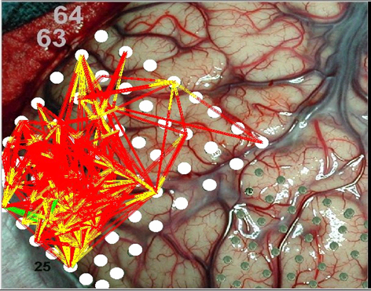
Figure 1 Examples of connectivity networks constructed from multi-channel recordings. Left: an example of connectivity network constructed from ECoG recordings of frontal lobe activity. In this case, each line between two electrodes represents the level of coherence between the recorded activities at the two locations (courtesy of V. L. Towle). Right: an example of cultured network activity recorded by multi-electrode array. In this case, the lines represent the level of the inter-neuron correlations between the individual neurons activities. The gray levels indicate the level of coherence in the first case and of the correlations in the second.

.

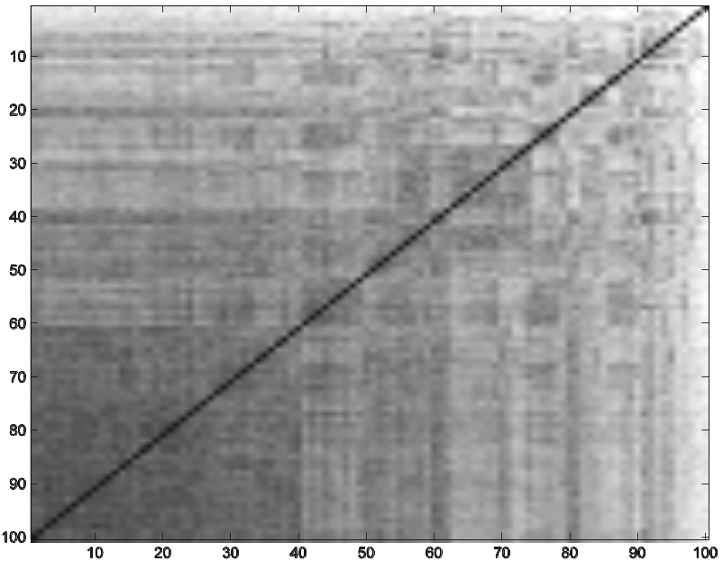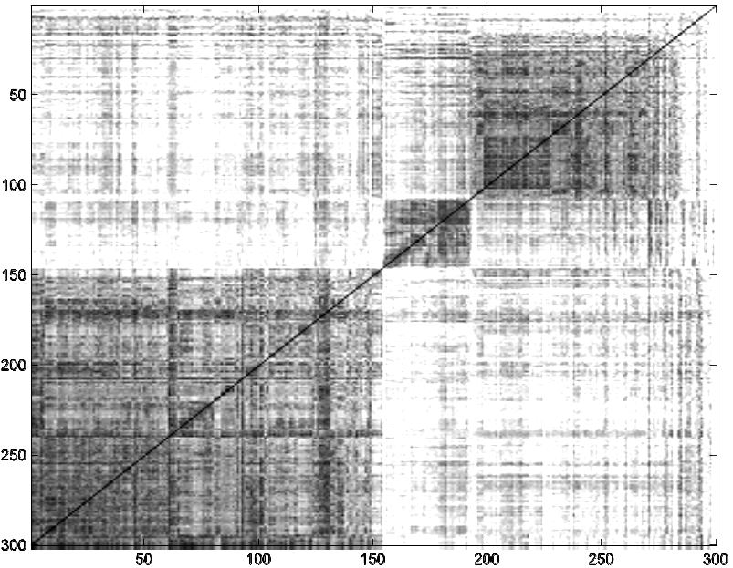

- a - - b -

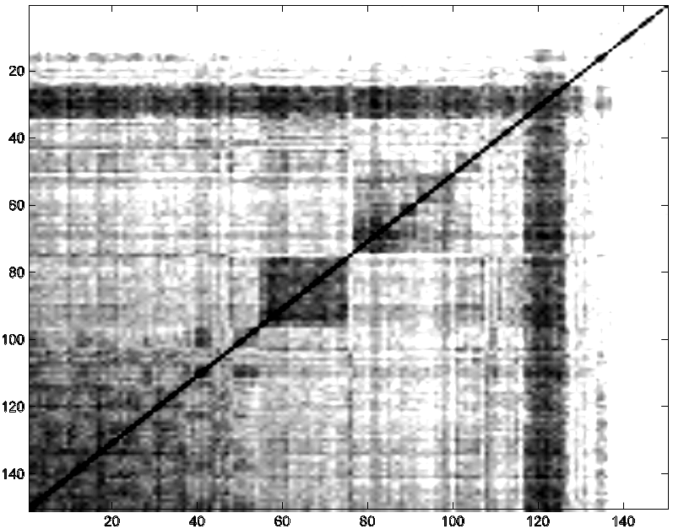
- c- - d -
Figure 2 Examples of dendrogrammed inter-SBEs correlation matrices for recordings from four different cultured networks. Each element (n,m) in the matrix represents the level of EC(n,m) by intensity of gray (white – low; black - high). A typical example of a matrix which has no partitioning into distinguishable sub-groups of SBEs is shown in (a). This is the typical result for small networks, i.e. at or below the characteristic size of the elementary networks (~1mm² and ~ 10⁴ neurons). The other three examples are for larger networks. The matrix in (b) shows a clear block partitioning. The matrix in (c) shows a clear band of SBEs that have high correlations with all the other SBEs. The matrix in (d) is of a recorded sequence of 150 SBEs in the presence of different calcium levels: events no. 1-50, 51-100, and 101-150 correspond to 0.5mM, 2mM, and 1mM extra-cellular Ca⁺⁺ respectively [Segev et al 2001a,2001b, 2004].

- a - - b -
Figure 3 The spatio-temporal patterns of propagation of the neuronal activity for the two sub-groups of SBEs of the cultured network that gives block partitioning in Fig. 2b. (a) is for the block on the left in the correlation matrix - sub-group (I), and (b) is for the block on the right - sub-group (II). The temporal locations T^{n}_{i} are represented by color dots around the neuron locations in real space. Blue is for early timing (positive “phase”) and red for late timing. The results illustrate that each sub-group of SBEs has its own characteristic pattern of activity propagation.

- a - - b -
- c - - d –

- e -

- f -
Figure 4 Representation of the inter-neuron correlation matrices as connectivity networks in "real space" (a,b), the corresponding correlation circle (c,d) and the corresponding holograms (e,f).The networks (a,c,e) correspond to sub-group (I) of SBEs and (b,d,f) to sub-group (II). In "real space" the neurons are positioned according to the electrode locations (the numbers are the electrode numbers) and connected by lines which represent their correlations C(i,j) using the same color code. Only correlations above 0.55 threshold levels are shown. The correlation circles (c,d) are constructed using the Dendrogram algorithm to order the neurons along a circle and then link them according to their correlations C(i,j), as done for the "real space" representation. The connectivity diagrams in the causal manifolds (e,f) are constructed as described in the text. In these holograms, the mesh on which the neurons are positioned shows the topology of the manifold. The color code of the mesh indicates the height of each location relative to the X-Y plane. The mesh is constructed by interpolation (analytical continuation) between the neurons locations. In these figures correlations above 0.5 are shown. Note that some of the correlations are not seen as they are behind the mesh for the angle of view used in the presentation. For example, in (f) neuron (6) has many links as can be seen in (d) that are behind the mesh. The coloring of the neuron locations represents their averaged "temporal location", i.e., the averaged T^{i}_{n} over the SBEs which belong to the same sub-group. By doing so, we discover the correspondence between the structure of the connectivity diagram and the temporal propagation of the activity. For sub-group (I), the activity starts at the sub-group of neurons (24,25,26,44), consequently, it propagates along the arch (27,22,19,5) to the sub-group of neurons (13,27,28,37), and terminates at neuron (6) which is probably an inhibitory one. Based on this, we propose that the two clusters of neurons, (24,25,26,44) and (13,27,28,37), belong to two overlapping elementary networks with neurons (27,22,19,5) being the mediating ones. The situation for sub-group (II) is very different. In this case, the activity starts at neuron (13) and propagates along the main group of neuron (22,20,27,5,44,19,28,26) and ends at the remote neurons (24,37) on one side and (6) on the other. Put together, the analysis helps reveal that each kind of SBEs is associated with its own special connectivity diagram, and that the individual neurons assume different functional roles in the different diagrams.

- a - - b -

- c - - d -

- e - - f –

Figure 5 Additional illustrations of unscrambling recorded activity in the space of affinities.
The top two pictures show the effect of calcium stress on the network activity for 1.0nm (a), and 2.0nM (b). The recorded activity is taken from [Segev and Ben Jacob, 2001]. The idea in inducing calcium stress is to imitate seizure-like activity. Looking at the raster plot of the recording reveals more intense activity reminiscence of that observed in brain activity during seizure [Towel et al, 1999]. Looking at the corresponding connectivity diagram reveals that the functional structure becomes less organized (random matrix corresponds to spherical diagram). Interestingly, the temporal propagation of the activity on the causal manifold is not arbitrary, as shown in (c) and (d). In these figures, the mesh on which the neurons are positioned is the causal manifold of the connectivity diagram shown in (a). For clarification, we do not link the neurons according to the correlations. Instead, we plot the mesh that shows the local and global topology of the causal manifold. The color code of the mesh indicates the heights above the X-Y (horizontal) plane. The angle of view in (c) is the same as in (a). The angle of view in (d) was selected to elucidate the correspondence between the topology of the manifold and the temporal ordering of activity propagation on the manifold. Note that it starts at the upper right corner, goes down to the valley on the right, rises again in the center (neuron 19), and ends in the valley on the left. In (e), we show an example of another cultured network whose connectivity diagram in the causal manifold has less organized structure. The picture in (f) shows the results after the network has been cut into two parts – a “dissection operation”. As could be expected, the activity splits into two functionally distinct connectivity diagrams. Interestingly, one of the networks seems to adjust itself so that the activity is even more ordered than that of the whole network before the operation. Such studies might be able to provide clues about real operations of in vivo networks.

Formally, D(i,i)=0 and hence the diagonal elements A(i,i) are ill-defined. However, due to the inherent neuronal plasticity and to noise, there should be uncertainty in the auto-correlation C(i,i) and therefore in the neurons positions in the correlation space. The latter can be translated into position uncertainty and thus into finite A(i,i), which is related to the effective noise level and neuronal plasticity, as will be detailed elsewhere. Here, for simplicity, we take C(i,i) to be C₀, the averaged noise level in the correlations. D₀=C₀ and therefore A₀≈1/C₀.
Note that the proper dimensionality of the manifolds is limited by the experimental recording noise, the experimental “statistical noise” (the number of channels and the recording time), and the variations in neuron activity that reflect their inherent plasticity. Therefore, only manifolds limited to few dimensions are expected to be statistically significant. We found the 3-D manifold statistically significant for our recordings of cultured network activity, so here we consider this specific case only.

